Instructions

In Tableau, create a new and original visualization of ONE of the data sets you analyzed for Lab #1. Try to improve and/or expand on the earlier visualization by (1) telling the same story better and/or (2) by telling a different story.

Aig140 Assignment 1

Advanced Data Visualization

Group Members: Aliyyah Jackhan, Masoud Masoori, Jonathan Chacko & Mohammed Aadil

Contents

Introduction 2

Lab 1 2

Visualization 1 2

Visualization 2 4

Visualization 3 5

Improved Visualization 6

The Story 6

Differences 6

Comparison of the New Visualization and the Original 7

Original Visualization 8

New Visualization 9

Conclusion 9

# Introduction

The initial dataset utilized in Lab 1 contained a limited number of data points, which restricted our ability to enhance the visualizations effectively. Therefore, we decided to repeat Lab 1 with an improved dataset to better demonstrate our acquired knowledge. We selected the #MakeoverMonday dataset for January 2025, featuring the Top 100 Games on Steam, as it aligns with our interests.

# Lab 1

## Visualization 1

**Top Games Played on Steam #MakeoverMondays** by [Ewaoluwa Osunrayi](https://public.tableau.com/app/profile/ewaoluwa.osunrayi)

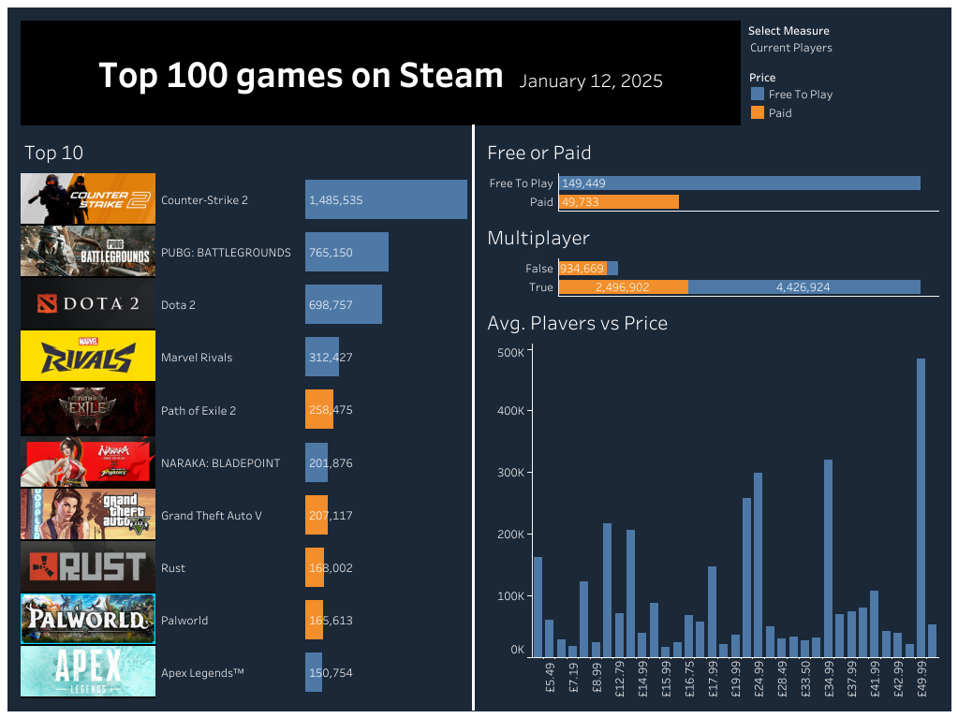

The visualization showcases the top games played on the Steam platform, highlighting key metrics such as the number of current and peak active players, game titles, logos, category if it is free or paid and chart showcasing average player per game and price. The intent is to provide insights into the most popular games among the Steam community.

The elements we should keep are:

* **Game Titles and Player Counts:** These are fundamental to understanding which games are leading in popularity.
* **Colour Coded Charts:** These colours bifurcate between paid and free to play games
* **Visual and numerical Elements (e.g., Bar Charts):** These effectively convey the data in an easily digestible format.

The elements we should change are:

* Keep the visualization more evenly space rather than being clustered
* The pricing in the vertical bar graph can be more normalized instead of having .99 format to make it easier to understand

The elements we should add are:

* **Interactive Filters:** Incorporating filters (e.g., by genre, release date) would allow users to customize their view and gain more personalized insights.
* **Trend Indicators:** Adding elements that show trends over time (e.g., player count growth or decline) can provide context on a game's trajectory.
* **Audience Age Factor:** By using this, we can understand what sort of age group is interested in which genre and what sort of games
* **Previous Top 100 Games by Year:** Through this gaming developers or industries can understand the pattern and the growth of genre by doing the analysis and make strategic decisions on which game to develop next or which update to bring to their existing games to keep the audience more invested

Ewaoluwa's visualization effectively highlights the leading games on Steam, offering a clear snapshot of current player preferences. By integrating interactive elements and trend data, it could evolve into a more dynamic tool, enabling users to explore the data more deeply and uncover patterns or shifts in gaming trends.

## Visualization 2

**#MakeoverMonday week3 2025 | Steam Top Games** by Vincenzo Borrelli

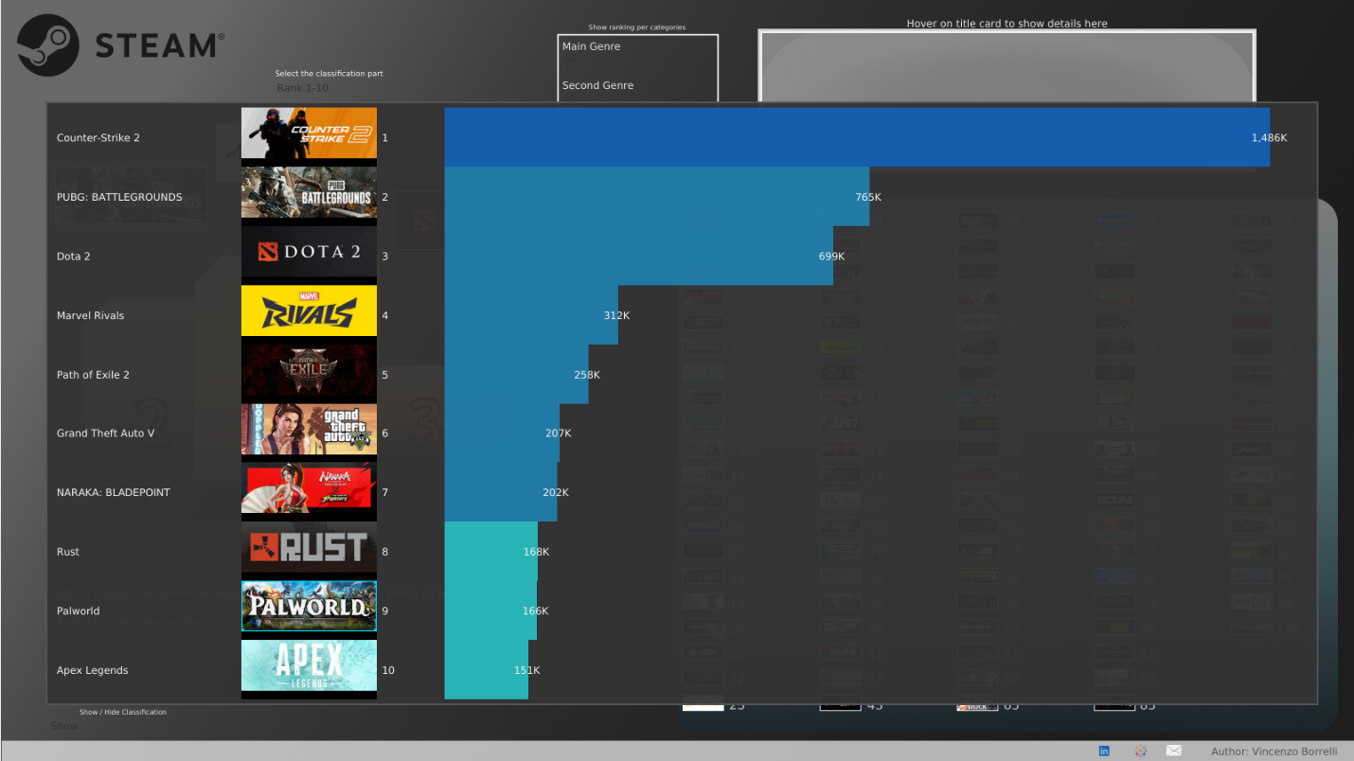

The image represents the top 10 most-played games on Steam based on simultaneous player counts. Counter-Strike 2 is the top of the list with 1.48M players, nearly double the second-most played game (PUBG: Battlegrounds at 765K).

The elements we should keep are:

* The game names
* The images of the games
* The number of players
* The meaningful length between the gamers (size efficiency shows the difference)

The elements we should change are:

* We can change the background as it does not match with all colors and game’s images

The elements we should add are:

* Changing the color of background
* We can add a percentage
* The place for ordering from 1-10 should change

PUBG, Dota 2, and Marvel Rivals are major contenders. With some improvements (better text readability, percentage change indicators, color-coded trends), this visualization can be even more insightful and engaging.

## Visualization 3

**#MakeoverMonday 2025 W03 - Steam Top 100 Played Games | VOTD** by Anna Clara Gatti

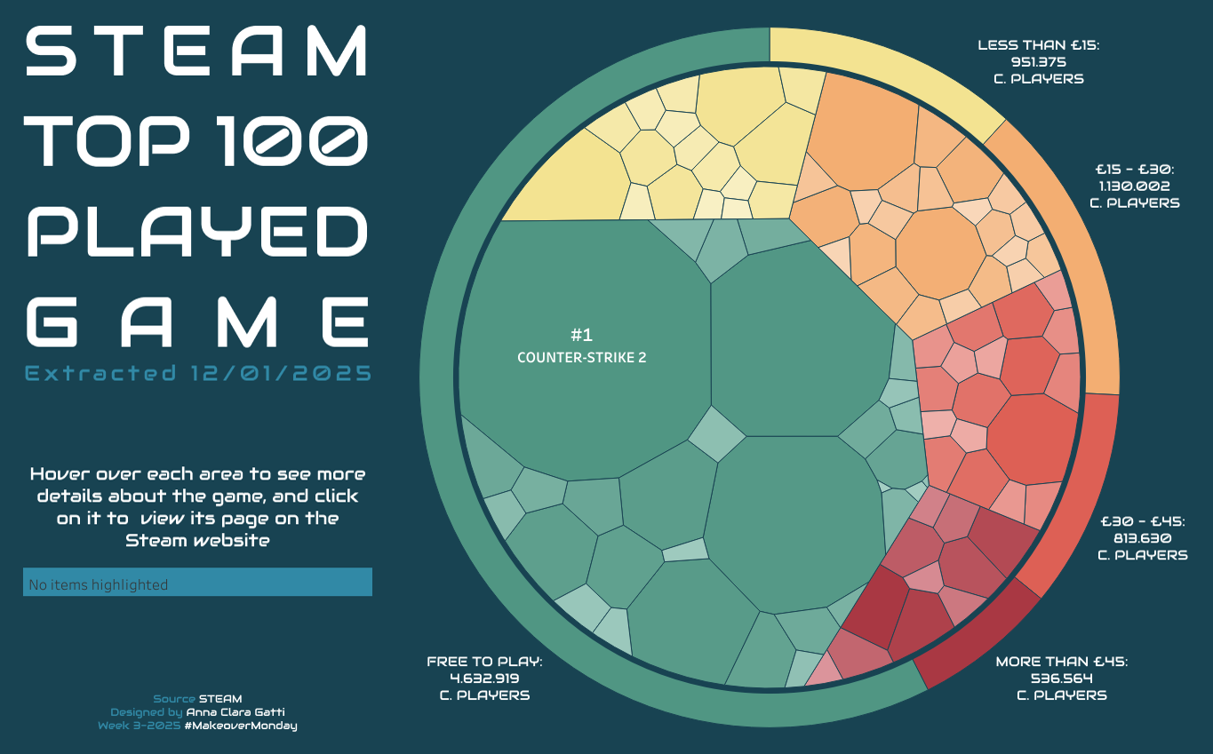

The visualization represents the Top 100 Most Played Steam Games. The larger the segment, the more popular the game. Games are categorized by price: Free-to-Play, <€15, €15-€30, €30-€45, and >€45. The most played game is Counter-Strike 2.

The elements we should keep are:

* The interactive design in the Tableau workbook, which allows users to hover over a segment to see game details
* The circular layout, which is visually appealing
* The price-based grouping, which helps viewers identify how pricing affects popularity.

The elements we should change are:

* The extracted date as it can be incorporated into the title for better readability
* The instruction to hover over each area

The elements we should add are:

* **Title Change** for better clarity
* **Bar Chart Addition:** A bar chart would make it easier to compare the number of players per game and highlight price-based trends
* **Highlighting the Top 5 or 10 Games:** Instead of focusing solely on the most played game, emphasizing the top 5 or 10 would provide a broader perspective on popularity.

This visualization tells a story of accessibility in gaming—Free-to-Play games dominate, showing that affordability is a major factor in player engagement. Counter-Strike 2 leads the charts, reflecting its enduring popularity and competitive appeal. Meanwhile, premium games (>€45) attract fewer players, suggesting that gamers lean towards lower-cost or free content. This trend highlights the impact of pricing on game popularity and the strong appeal of free-to-play models in the gaming community.

# Improved Visualization

## The Story

The visualization is designed to address a common challenge faced by gamers: deciding what to play next. With thousands of games available on platforms like Steam, it can be overwhelming for users to sift through options and find games that match their preferences. This dashboard simplifies the process by providing a user-friendly interface that allows gamers to explore the *Top 100 Games* based on their specific interests.

The dashboard offers three key filtering options:

* **Category:** Users can explore games by genre (e.g., action, adventure, strategy, RPG, etc.).
* **Price:** Gamers can filter games based on their budget, whether they are looking for free-to-play games, affordable indie titles, or premium AAA games.
* **Multiplayer:** Users can specify whether they want single-player, co-op, or competitive multiplayer games.

By allowing users to input their preferences, the dashboard generates a curated list of games tailored to their tastes. For example, a user who prefers *action-packed multiplayer games under $20* can quickly find recommendations that fit their criteria. This personalized approach not only saves time but also enhances the user experience by making game discovery more intuitive and enjoyable.

## Differences

The new visualization improves upon the original in several ways:

1. **Enhanced User Preferences**

The original visualization may have provided a static list of top games without considering individual preferences. In contrast, the new dashboard allows users to input their preferences (e.g., genre, price range, multiplayer options) and generates a customized list of recommendations. This makes the experience more interactive and user centric.

2. **Dynamic Top 10 Lists**

While the original visualization might have displayed a single, general ranking of games, the new dashboard breaks down the Top 10 games in every category or context selected by the user. For instance, if a user selects "Action" and "Under $30," the dashboard will display the top 10 action games within that price range. This granularity helps users make more informed decisions.

3. **Improved Visual Design**

The new visualization likely features a more modern and intuitive design, with interactive elements like dropdown menus, sliders (for price ranges), and clickable filters. These enhancements make it easier for users to navigate and explore options compared to the original static or less interactive design.

4. **Focus on Personalization**

The original visualization may have been more generic, offering a one-size-fits-all approach. The new dashboard, however, emphasizes personalization, ensuring that each user receives recommendations tailored to their unique preferences.

### Comparison of the New Visualization and the Original

To fully appreciate the improvements, it’s important to compare the new visualization with the original. Below is a description of both:

### Original Visualization

* **Static List**: The original visualization likely displayed a static list of the Top 100 Games without any filtering options.
* **Limited Interactivity**: Users could not customize the list based on their preferences.
* **General Rankings**: The games were ranked based on overall popularity or sales, without breaking them down into categories or contexts.
* **Basic Design**: The design may have been simpler, with fewer interactive elements or visual aids.

### New Visualization

* **Interactive Dashboard**: The new visualization is an interactive dashboard that allows users to filter games by category, price, and multiplayer options.
* **Customizable Recommendations:** Users can input their preferences and receive a tailored list of games.
* **Top 10 Breakdown:** The dashboard displays the Top 10 games in every selected category or context, providing more focused recommendations.
* **Modern Design:** The new design is likely more visually appealing, with interactive elements like dropdowns, sliders, and dynamic charts.

## Conclusion

The new visualization represents a significant upgrade over the original by focusing on personalization, interactivity, and user experience. It empowers gamers to discover games that align with their preferences, making the process of finding the next game to play both efficient and enjoyable. By breaking down the Top 10 games in every category and context, the dashboard provides a more granular and actionable insight compared to the original static list.